The Language of Play: Exploring the Bridge between Art and Therapy
Introduction
This essay explores how play serves as a bridge between art and therapy, revealing its power to transform and heal. “Toys are children’s words and play is their language.” (Landreth, 2002) This quote speaks volumes to me. I’ve always been drawn to the world of children’s play, a space where heart, mind, and soul come together. For many children, especially those with communication challenges, play is a natural and essential way to express themselves. It allows them to communicate when words fall short.
During my time as a residential support worker at a boarding school for Deaf children with special needs, I witnessed the profound power of play. Many struggled to verbalise their emotions, but when given a puzzle, doll, Lego set, or art supplies, their inner world would come alive. I could relate. As a teenager, I often lacked the words to describe my emotions. That frustration remains with me; this gives me empathy for the comfort and freedom these children find in play.
Through this work, I’ve come to see toys and creative materials as allowing emotions to surface in ways words often cannot. In this essay, I will explore how these experiences influence my artistic practice, particularly my use of playful objects, wearable structures, and performance to explore the themes of vulnerability, safety, and connection. I aim to investigate how play functions as both an expressive medium and a therapeutic tool.
As play therapist Susannah Bradley explains:
“Play therapy is a fantastic way of giving someone a way of exploring their feelings and emotions if they don’t have the vocabulary to understand or explain these feelings. It can give them the tools they need to develop relationships in the future and to believe in themselves.” (Bradley, n.d.)
Even in ancient times, the value of play was recognised:
“You can discover more about a person in an hour of play than in a year of conversation.” (Plato, c. 380 BCE, translated 2003).
This resonates deeply with my own observations of how play opens up emotional expression where words cannot.
The Role of Play in Therapy
Children often process their experiences and understanding of the world through play. It serves as a bridge to self-awareness and social understanding. One widely used approach is child-centred play therapy, where a child works one-on-one with a therapist in a supportive space. Through play, recurring themes emerge; offering valuable insights into the child’s their inner world. Over time, the therapist gently helps the child to explore these meanings, supporting emotional growth, self expression, and healing.
Play therapy can be especially beneficial for children struggling with low self-esteem, anxiety, helplessness, or feelings of inadequacy, often challenges that stem from difficulties in learning or academic challenges. Designed for children between the ages of 3 to 11, it creates a safe, natural space where they can explore and process their emotions at their own pace.
Sometimes play therapy is chosen when there are concerns about the child’s home environment, such as abuse, neglect or a lack of parental support. However, even in the absence of trauma, this one-to-one space offers a child a rare sense of security, autonomy, and emotional safety.
Types of Play Therapy
Play therapy has been effectively used to support children with a range of challenges, including behavioural issues, anxiety, ADHD, PTSD, autism, and trauma-related difficulties. There are two main types of play therapy:
▪ Directive play therapy - therapist guides structured activities.
▪ Non-directive play therapy - child leads the session.
These methods empower children to express themselves in ways that feel natural and non-threatening. Play therapy meets them at their level, using familiar toys, games and materials to create a space where they feel seen, heard and understood.
“When you’re free, you can play. And when you’re playing, you become free.” (Kadison, n.d.).
Sometimes, children express their inner pain in subtle but powerful ways, saying things like, “Everybody hates me and I do too.” But when a child picks up a toy and begin to act out a story, they’re sharing emotions they may not yet have the words to express.
Emotional Expression and Healing
It’s well understood that children naturally learn and grow through play. Play therapy builds on this instinct, offering a structured yet flexible space where healing can begin. With the gentle presence of a trained therapist, the child is free to explore their world without fear of judgment or interruption. As Susannah Bradley explains, “Its mainly child led. As play therapists, we don’t interpret, we don’t react, we don’t judge.” (Bradley, n.d.).
Some of the children I’ve worked with have said things like, “I want home,” or “I’m very anxious.” Others simply tell me they just want to stay inside because that’s where it feels safe. Hearing those words always hits me deeply. It’s a reminder that, beyond behaviour or diagnoses, there’s a child longing for comfort, security and connection.
Art and Play in Creative Practice
These moments remind me that creating art with children is not just about the final product. It’s about showing up with empathy, holding space for fear, sadness or longing. A simple drawing or small gesture can become something solid to hold onto, a way for them to be seen.
One client repeatedly asked to go to the toy shop.” When I finally asked why, she said, “It makes me feel anxious, but I also feel loved and not so alone.” That experience helped shape my intention: to explore how person-centred thinking can influence my installation work.
Artist Case Studies
Mike Kelley
Kelley’s installations, such as Educational Complex (1993), speak of trauma, neglect and systematic failure. His use of worn, discarded toys communicates childhoods that weren’t idealised but real, raw and emotional.
In my own sessions, I’ve seen the same thing, how toys carry meaning far beyond play. One young girl said the toy shop made her feel “less anxious and not alone.” I understood. For some children, toys aren’t just fun. They’re bridges to safety, connection and meaning. Like Kelley, I want to use toys in my work not as symbols of idealised childhoods, but as witnesses to real emotion.
However, instead of solely using installation or sculpture, I’m drawn to drawing, performance, and painting. I want to create spaces where the toy speaks, where it represents the child’s unheard voice, a protector, or a quiet observer. Play therapy has taught me that toys are powerful, they can hold what can’t yet be said. Kelley’s raw honesty inspires me to create work that honours that silence, that deep place where emotion hides until it feels safe to come out.
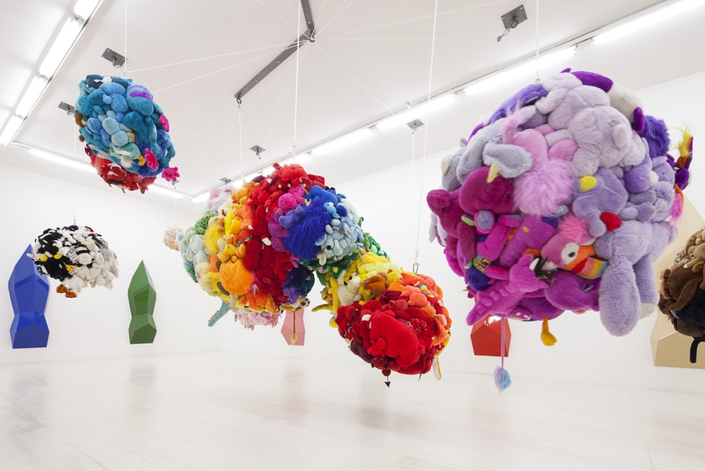

Annette Messager
Messager’s use of soft materials, and toys creates landscapes of identity and vulnerability. Her work often addresses femininity and memory in ways that feel intimate and surreal.
I often choose soft materials in my work, fabrics, cushions, or gentle textures, because they evoke a sense of comfort and care. The choice is influenced by ideas from sensory integration and trauma-informed design, where soft, non-threatening environments can help regulate the nervous system. In my work with children, especially those with sensory needs or emotional difficulties, I’ve seen how softness can calm, ground, and create safety. These materials also relate to Winnicott’s theory of the “holding environment”, the idea that care, containment, and emotional holding are essential for development. Through my installations and performances, I try to create that same sense of being held, gently, without pressure, for both myself and for the viewer.
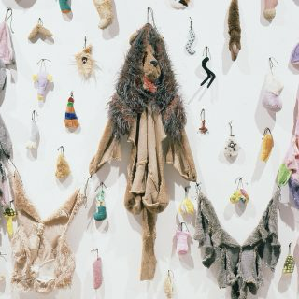

Polina Osipova
Osipova merges folklore images with performance to explore personal and collective healing. Her art resonates with my own experience of care and transformation.
Art helps us to reclaim what’s been forgotten. For me, using folkloric imagery, especially Romani and ancestral elements, allows me to reach places language cannot .It becomes a way to heal history, both personal and collective .Osipova does this, too, transforming grief into performance and memory into art.
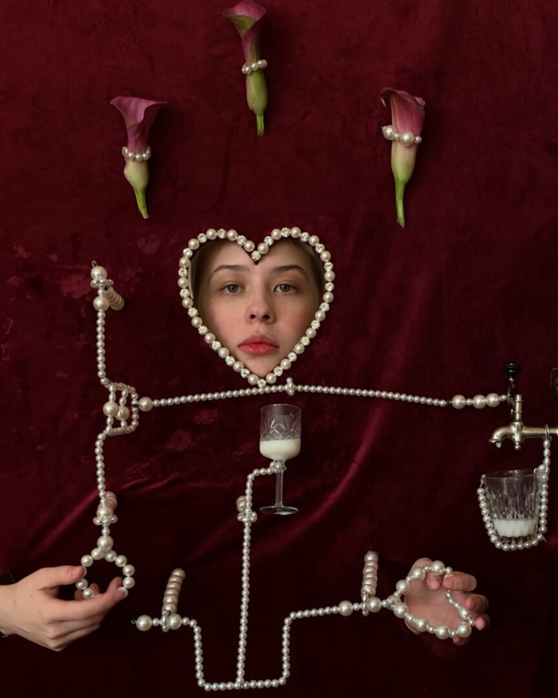

Psychological and Artistic Perspectives on Play
1. Emotional Expression and Regulation
Children often don’t have the words for sadness, fear, or anger. But give them a pencil, some clay, a doll, and they’ll show you. A crayon storm might be their inner chaos. A tiny clay house might be the safety they crave.
Through this symbolic language, caregivers can begin to see what children are feeling, and children themselves begin to understand those feelings, too.
2. Building Confidence and Identity
Art tells children: you matter.
When they choose colours, make marks, tell stories, it builds self-esteem. It teaches decision-making. It gives a sense of who they are, especially vital for children who feel invisible or have experienced trauma.
3. Healing Trauma and Navigating Change
Loss. Violence. Displacement. Separation. These are things many children face but can’t always talk about. Art therapy opens a gentle path. It allows access to emotion without forcing language. It brings healing without reopening the wound.
Developmental Role
Piaget saw symbolic play as a sign of cognitive maturity. Vygotsky viewed it as essential for social learning, where children absorb rules and norms (Vgotsky, 1978).
1. Play in Psychology
a. Developmental Role
Play helps kids grow emotionally, socially, and cognitively. Piaget saw symbolic play as a sign of cognitive maturity. Vygotsky viewed it as social learning, where kids absorb culture, language and rules (Vygotsky, 1978).
b. Therapeutic Role
In therapy, play becomes language. Sand trays, puppets and dolls give access to inner worlds, especially in trauma recovery.
2. Play in Art
a. Creative Process
Artists play with meaning, form, colour, material. Movements like Dada and Surrealism embraced absurdity and randomness. Contemporary artists like Kusama and Basquiat use playful forms to express deep emotional truths.
b. Experimentation
Play in art means taking risks. It blurs the line boundaries between artist and viewer, especially in performance. Marina Abramovic’s interactive works are examples of serious play pushing emotional and psychological boundaries.
3. Shared Power of Play
Whether it’s a child working through fear with toys or an artist challenging norms with paint, play is a powerful tool. It helps us connect, release, and understand ourselves. In therapy, it supports healing. In art, it drives meaning making, it helps us to learn, cope and tell our stories.
Art therapy is where all of this comes together. It’s not about producing “good” art, it’s about creating honest and expressive art. It uses colour, symbol and performance not only to express, but to heal.
Creative Role in Art
Several artists use play to challenge norms, explore new ideas and express themselves, or to create strong emotional reactions.
Pipilotti Rist’s innovative approach to video art and immersive installations have significantly inspired my practice. I hope to pursue an MA in Fine Art to continue developing my artistic practice, with a particular focus on video installations that reflect my experiences working with children in educational settings, such as sensory rooms. These experiences have deeply affected me, especially witnessing the emotional struggles of some clients who prefer to stay at home. Through my work, I hope to evoke empathy and raise awareness of these emotional and social realities.
Lygia Clark has influenced my approach to performance drawing, particularly in the way I engage with repetitive forms. My work often incorporates circular shapes; I am interested in exploring why I am drawn to the circle and what symbolic or emotional meanings it might hold. I’ve started to reflect on why. In my experience working with children, particularly in educational or therapeutic settings where I often encountered repetitive behaviours. Some children were resistant to change, caught in emotional loops or displayed a stubborn need for consistency.
These moments were challenging, but they taught me patience and deepened my sense of empathy. I now see the repetition of circles in my work as a reflection of those experiences, perhaps a way to process or contain the emotional weight of that environment. In my performance drawing, I move slowly and calmly, almost meditatively. I don’t respond well to stress or anxiety, and drawing becomes a way to resist that pressure, a quiet act of care, both for myself and those I’m thinking about as I work.
Ernesto Neto’s immersive installations have inspired me to rethink the relationship between space, the body, and materials. His use of soft, organic forms and multisensory experiences has had a strong influence on my own ideas for installation work. During my MA in Fine Art, I hope to develop this further by creating own sensory-based installations that explore similar themes, with the aim of eventually exhibiting them as part of my ongoing artistic practice.
Merging Art and Therapy – The Final Project
While fine art looks outward, art therapy turns inward. But for me, these practices blur. When I perform a ritual, wear a mask, or make a drawing, it’s not just for an audience. It’s for healing. For memory. For catharsis dressed in creative form.
As I develop my final project, I envision a sensory installation, a soft circular structure, wrapped in fabric, gently lit, and filled with materials that invite touch, movement, and curiosity. It will be guided not just by visual aesthetics, but by emotional intention: how the space feels to enter, how it may calm, comfort or spark connection. This vision is rooted in my work with children in specialist care settings and my growing interest in the therapeutic potential of art spaces.
My goal is to create work that lives between disciplines: art that embodies care, and therapeutic experiences that carry the poetics of creativity. Whether I pursue further study in fine art, play therapy, or counselling, I know that this hybrid identity,—artist, carer, facilitator, will continue to shape how I create, connect, and listen.
Final Thoughts
Whether through a child’s drawing or an artist’s performance, art tells the truth. It reflects pain, identity, joy, confusion. My practice sits at the intersection of healing and expression. Where a drawing is both a cry and a breakthrough. Where art is not just a product, but a release. A witness, a voice of our inner thoughts and feelings.
Because for children, play is more than play, it’s how they speak. And when we listen, really listen, we can meet them where they are. And that’s where healing begins.
I believe play is not just an activity, it’s a doorway into emotional freedom, healing, and self-expression. In both therapeutic and creative spaces, play offers children, and all of us, a way to process, to connect, and to be seen.
Through my work in residential care and my evolving creative practice, I’ve come to understand that freedom doesn’t always begin with words. Sometimes it begins with a toy, a drawing, a costume, or a quiet moment of imagination. These are not small things, they are bridges to safety, joy, and identity.
As I move forward, I carry with me the voices and gestures of the children I’ve supported, the inspiration of artists who blend emotion and material, and my own desire to create spaces where care and creativity coexist. Whether through therapy, installation, or fashion, my goal is to keep listening, keep making, and keep honouring the quiet power of play.
Because to play is to hope. And in that freedom, transformation can begin.

References
Bradley, S. (n.d.) quoted in British Association for Counselling and Psychotherapy (2023). What is Play Therapy? [online]. www.bacp.co.uk. Available at: https://www.bacp.co.uk/about-therapy/types-of-therapy/play-therapy/ [Accessed 17 Jun. 2025].
Kadison, H. (n.d.) quoted in Core Wellness (2008). 10 Family Therapy Activities. [online] Core Wellness. Available at: https://corewellceu.com/blog/play-therapy-quotes/ [Accessed 17 Jun. 2025].
Kelley, M. (1993) Educational Complex. [Art installation].
Landreth, G.L. (2002) Play Therapy: The Art of the Relationship. 2nd ed. London: Routledge.
Messager, A. (n.d.) [Installations exploring identity, memory, and the body].
Osipova, P. (n.d.) [Performance works with folkloric and ritual themes].
Plato (c. 380 BCE) The Republic. Translated by D. Lee. London: Penguin Classics, 2003.
Vygotsky, L.S. (1978) Mind in Society: The Development of Higher Psychological Processes. Cambridge, MA: Harvard University Press.

